Intro to Programming with Scratch

Subject: Computer Engineering  Related Subjects:Programming | Grade Level(s):  Length of Lesson: | Type: Inquiry / Design / Project  Keywords:: Programing, Computer Science, Scratch

Lesson Overview
For this project I will be introducing the students to the field of computer science and programming. They will learn introductory programming terms and go through basic “Hello World” type lessons/tutorials in Scratch, an online free visual programming language.

Lesson Focus
What is the central question or phenomenon being investigated? What problem are they trying to solve?

Lesson Objective(s) | - Students will learn basic programming skills through easy Scratch tutorials and simulations.  - Students will learn computer science terms and the importance of sequences and debugging.

Lesson Timing

Time [min] | Description
5 | Introduce the Lesson  - End Goal  - Primer Questions  - Key Vocab Words
1 | Role Models in STEM
Engineering Method
5 | Real World Example
5 | Hypothesis & Prediction
5 | Brainstorm & Design
20 | Build & Create
10 | Test & Record
5 | Assess & Evaluate
5 | How to improve?
10 | Lesson Cleanup

Materials | - Mission Science laptops  - Scratch books/manuals  - Laptop chargers
Instructor Prep | - Step 1
Related Resources | - List related lessons/ppts etc available from USC or outside, trusted orgs

Lesson Plan

Introduction
- What is Computer Engineering?
  - The discipline that combines electrical engineering with computer science, including design, construction and implementation of hardware and software for computers.
- What are commands?
  - Instructions given by the user telling the computer to do a specific task.
- What is an algorithm?
  - An algorithm is a precise step by step guide to achieve a certain outcome.
  - An algorithm consists of commands, or instructions given by the computer user.

Computer Science is the academic field of study for computer engineering. Students will learn the basics of programming and computer engineering through easy tutorials in Scratch, a free online program. The purpose of this project is to expose these students to computer engineering terms to better prepare them for more complicated projects we will do in the future with Arduinos and other robotics.

Procedure
- Students will first learn programming vocabulary and basic terms.
- Have students work in pairs on each computer.
- Have students go to http://scratch.mit.edu/
- Students will explore the site/follow tutorials beginning with the “Hello, World!” tutorial.

Wrap-up
The purpose of the survey is to let us know your opinions about today’s project. Remember there are no right or wrong answers.

 |  | Strongly Disagree | Disagree | Undecided | Agree | Strongly Agree
1 | The project increased my interest in science
2 | After this project, I am more confident in doing science

3. What does a computer scientist/engineer do?

4. What is a programming language?

5. Why is it important for an algorithm to follow a sequence?

Lesson Background for Teachers

Suggested Real-World STEM Connections

Real World Example
- Every time you are surfing the internet, playing a computer game, downloading music, shopping online, or using your cell phone, all aspects of computer engineering and computer science are being applied.
- Computer engineers and scientists write the algorithms and commands your computers execute to perform the way they do.

Hypothesis & Prediction
- Students will write their own program with commands and predict how their scratch simulation will respond.

Brainstorm & Design
- What will the students be brainstorming solutions to?
- Have students identify what constraints they have. (Time, materials, etc)
- How will they overcome those constraints?

Build & Create
- Students will create their own scratch simulation using basic programming skills.

Test & Record
- How will the students test their design?
- What type of data will be recorded?

Assess, & Evaluate
- How will the students assess the degree of success in their design?

How to Improve?
- Ask the students what they would improve or change if they were to do it again

Role Model in STEM
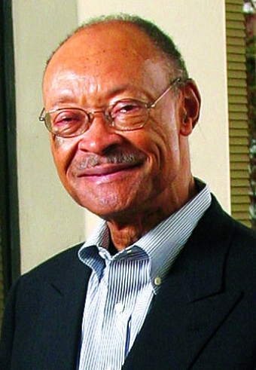

Name: Frank Greene
Years: 1938-2009
Quick Facts
- One of the first black electronics technologists and high-tech business executive.
- Served in United States Air Force as Electronics Officer for four years then began his research and development of a high-speed semi-conductor for computer memory systems.
- Inducted into Silicon Valley Hall of Fame
- Started two technology companies and became professor of computer science and electrical engineering at Stanford University.
Source(s):
- https://www.scu.edu/engineering/stories/celebrating-black-history-month-spotlight-on-frank-s-greene-phd-70-1938-2009.html
- http://www.paloaltoonline.com/news/2009/12/28/frank-greene-silicon-valley-technology-pioneer-dies-at-71

Lesson Variations and Options
Include descriptions of alternative methods or ways to present things.

Explanation
Students will experiment with easy tutorials to learn how to write their own algorithms that involve commands and sequences. Students will learn to debug their codes, since all computer scientists and programmers make mistakes as a natural part of the creative process.

Key Concepts and Vocabulary
- Programming language
  - A way to communicate instructions to a machine
  - A programming language provides the framework where a function can be executed with arguments. The arguments of a command usually define variables
- Scripts
  - Script is a computer language with a series of commands within a file that a computer can execute after being compiled.
- Commands
  - Instructions given by the user for the computer to do a specific task.
- Algorithm
  - A process or set of rules to be followed by a computer to do calculations.
- Sequence
  - A set of actions or events that must be carried out in the same order every time.
  - One of the three basic logical structures used by algorithms and programming.
- Debugging
  - The act of fixing or correcting algorithms or programming code

Safety Notes
- Safety instruction

